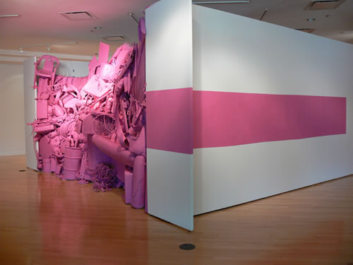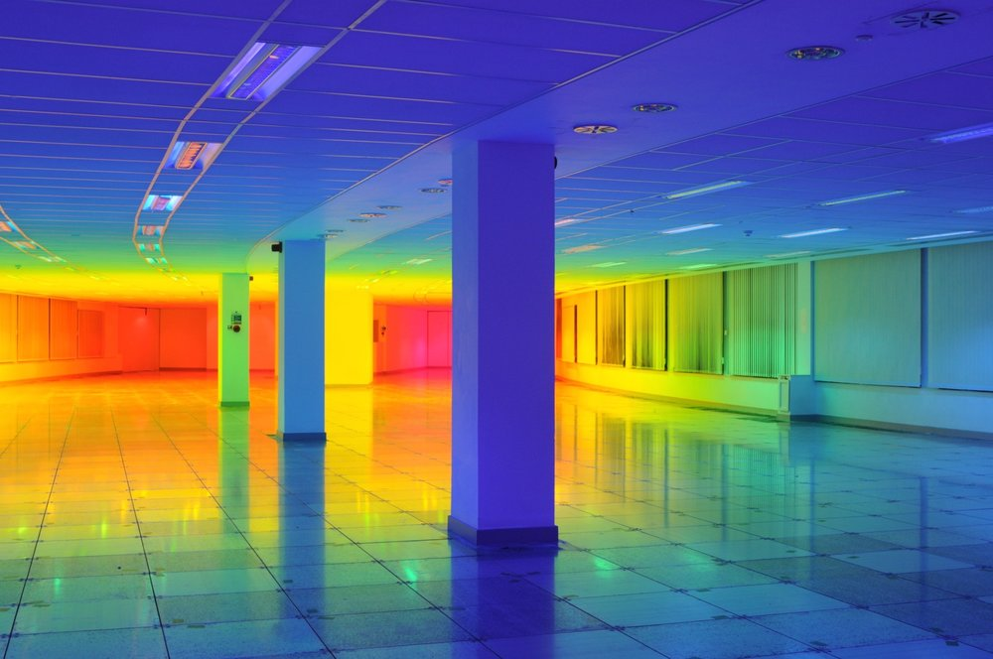
Marc Anthony-Polizzi Liz West
Teacher: Simone Williams
Lesson Title: Color Installation
Grade: 8th
Brief History: History: “Installation art is a term generally used to describe artwork located in three-dimensional interior space as the word "install" means putting something inside of something else. It is often site-specific - designed to have a particular relationship, whether temporary or permanent, with its spatial environment on an architectural9.1.8B. Recognize, know, use and demonstrate a variety of appropriate arts elements and principles to produce, review and revise original works in the arts.
Standards: 9.1.12.F, 9.2.12.L, 9.3.12.B, 9.4.12.C
Goals: Create a walk through color installation
Objectives:
Students will know what monochromatic color schemes are in order to collect the right materials
Students will learn what installation art is and how to construct an installation. Student will learn how to think of art in a more abstract way.
Students will know what an installation is and the process to creating an installation piece and will have the opportunity to work on large surfaces and collaborate with other students.
Requirements: Hand in item placement sketches
Recourses/Materials/Visual Aids:
Artist examples
Student examples
Supplies/Materials:
Large surfaces (dry wall, board or cardboard)
Acrylic paint
Paint brushes
Found objects
Elmer’s glue
Super glue
Hot glue gun
Teacher Preparation:
Class color or pattern
All mark making supplies and tools
Lesson presentation
Artist lecture and PowerPoint
Extra found objects
Large surfaces (dry wall, board or cardboard)
Approval from principle, staff
Critique/Evaluation/Assessment:
Extensions: Second peer drawing, free draw
Time Budget: 3 Weeks (45min class)
Day 1: Introduction of Marc Anthony-Polizzi and Liz West and Color installation project
Day 2: Lesson outlined and explained. Class colors or pattern decided
Time to find objects.
Day 3: Marc Anthony-Polizzi and Liz West refresher. Found or desired materials due.
Sections laid out
Group item placement hand outs
Day 4: Studio Day
Sketching and collecting items
Time to find last minute objects around school and outside
Day 5: Studio Day
Beginning of in class work on large surfaces.
Week 2
Day 1: Studio Day
Day 2: Studio Day
Day 3: Studio Day
Day 4: Studio Day
Day 5: Studio Day
All items on surfaces need to be placed and secured.
Week 3
Day 1: Studio Day
Day 2: Classes meets in art room first then walk to auditorium to begin construction of installation.
Day 3: Continue to construct installation.
Day 4: Final day to work on installation.
Day 5: Family, friends and staff invited to walk through installation.
Vocabulary: Installation art, Site specific, Focus
Safety Concerns: Hot glue gun, construction of installation
Bibliography/References:
http://www.theartstory.org/movement-installation-art.htm
https://mymodernmet.com/what-is-installation-art-history-artists/

