Name: Simone Williams

Image:
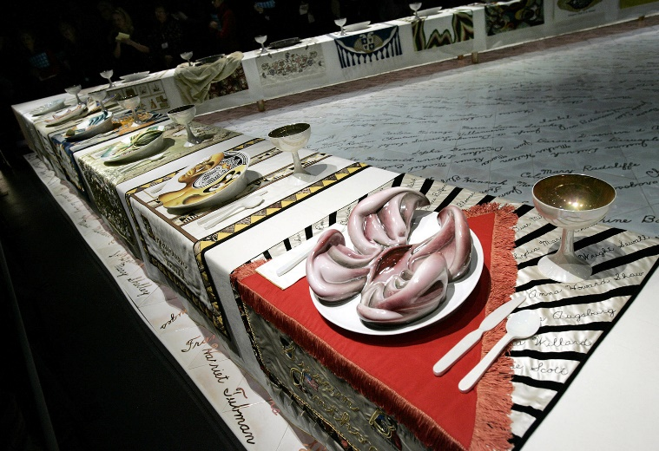
Judy Chicago - The Dinner Party

Lesson Title: A Dinner Party Plate

Grade Level: 9th

History/ Background: “The Dinner Party, an important icon of 1970s feminist art and a milestone in twentieth-century art, is presented as the centerpiece around which the Elizabeth A. Sackler Center for Feminist Art is organized. The Dinner Party comprises a massive ceremonial banquet, arranged on a triangular table with a total of thirty-nine place settings, each commemorating an important woman from history. The settings consist of embroidered runners, gold chalices and utensils, and china-painted porcelain plates with raised central motifs that are based on vulvar and butterfly forms and rendered in styles appropriate to the individual women being honored. The names of another 999 women are inscribed in gold on the white tile floor below the triangular table. This permanent installation is enhanced by rotating Herstory Gallery exhibitions relating to the 1,038 women honored at the table.”

Standards:
9.1.8. C- Identify and use comprehensive vocabulary within each of the arts forms.
9.1.8. D- Demonstrate knowledge of at least two styles within each art form through performance or exhibition of unique works.
9.3.8. C- Identify and classify styles, forms, types and genre within art forms.
9.3.8. F- Apply the process of criticism to identify characteristics among works in the arts.

Goal: Create a ceramic dinner party plate (can be functional or not).
Objectives:
Knowledge: Cognitive- Students learn slab building and hand building.
Skill: Psychomotor- Students learn how to create plates using clay slabs and plate molds. Students learn how to secure a hand built ceramic piece onto a ceramic plate.
Attitude: Affective- Students become more aware of different methods of working with clay. Students become more aware of Judy Chicago’s influence on women in art.

Prepare Ahead:
Clay, glaze, re-sized slab roller, slip, food safe adhesive sealant.

Prior Knowledge: Students have had previous lessons on making coil pots, students have free hand built using clay before,

(Teaching):
Demonstration: Today we are using the slab roller to make our plates. (Students each grab a ball of clay and gather around the slab roller). Many of you have used a slab roller before, but I will demonstrate for those that have not. First, use a rolling pin or your hand to flatten the top and bottom of your ball of clay. Then, place your clay in between these two canvas sheets at least a six inches away from the roller. Then, rotate the handle until the roller passes over the clay. Rotate the handle in the other direction to pass over the clay again.
If you have an idea of what you want to make for your ceramic hand built piece during the next class, think about where that will be on your plate while you begin working today.

  - Visual Aids: Images of the person students chose or inspiration for the plate and the hand built ceramic piece
  - Reference to Art History: Judy Chicago
  - Exemplars: Plates from The Dinner Party, past student work

Activity: Students will create ceramic plates using slab building and hand building techniques.

Time Budget:
At home: Look up The Dinner Party by Judy Chicago, look up current influential/ inspirational women, no later than 1990. Students can choose someone in their life. Must write 2 paragraphs about them and how people or they individually are influenced by them.
Class 1 (45 min period): Slab plate building demonstration, working on plates
At home: Print or share link about The Dinner Party, 2 paragraphs about chosen person due next class.
Class 2 (45 min period): Working on the plates. Beginning hand building pieces.
A home: Look up different between pinch pot building and hand building.
Class 3 (45 min period): Working on the plates and the hand building piece. Adding hand built piece on top of plate using slip or after firing using food safe adhesive, kiln firing.
At home: Look up glaze and examples of how to paint with glaze.
Class 4 (45 min period): Firing, adhering hand built pieces to plates, glazing and painting, glazed firing.
Class 5 (45 min period): Glazing, final firing.

Supplies: Clay, glaze, slab roller, rolling pins, slip, adhesive

Vocabulary: Slab, Hand building, Glaze, Pinch Pot

Closure: Who can give me 2 names from Judy Chicago’s dinner table?

Critique/Evaluation/Assessment Strategy: Students will be assessed according to written assignments and their relation of work to the written assignments.

Extensions: Early finishers can make smaller pieces to add if the class is not done with firing.

Correlated Activity: Students will take their knowledge of hand building and create sculptures using polyurethane foam carving block. Lesson on Simone Leigh.

Interdisciplinary Domains: History

Adaptations: Visual directions, Student secretary.

Safety Concerns: Students will be using a slab roller. Teacher will demonstrate safe and proper way to use slab roller.

Bibliography/References:

The Dinner Party by Judy Chicago
Elizabeth A. Sackler Center for Feminist Art, 4th Floor
https://www.brooklynmuseum.org/exhibitions/dinner_party

​Flipped Classroom vs. Blended Classroom
https://teachwithict.weebly.com/flipped-classroom-vs-blended-classroom.html

THE ART CLASSROOM -FLIPPED
EXPANDING LEARNING BEYOND THE CLASSROOM.
https://www.smore.com/mjyt-the-art-classroom-flipped

