Project Planning
Name: Simone Williams

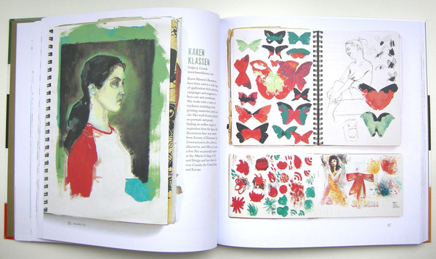
Karen Kassen’s sketchbook from Drawn In.
Lesson Title: Project Planning

Grade Level: Middle school

History/ Background: “Studio Practice is aimed at our more experienced, long-term artists. They work in a self-directed manner, identifying and developing ideas of their own choosing; they are encouraged to gather resources and undertake simple research towards their work”

Standards:
9.1.8. F. Explain works of others within each art form through performance or exhibition
9.1.8. K. Incorporate specific uses of traditional and contemporary technologies in furthering knowledge and understanding in the humanities.
9.3.8 F. Apply the process of criticism to identify characteristics among works in the arts.

Goal: Students will create a color key for one image and take notes directly on that source.
Objectives:
Knowledge: Cognitive- Students learn that, note taking on the source image for projects helps plan for the end goal
Skill: Psychomotor- Students learn how to, extract color from images using the eyedropper tool and other Photoshop skills. Students will learn how to, take notes digitally on works in progress. Using Google advance settings to look for large images
Attitude: Affective- Students become more aware of, the effectiveness of planning during the art process.

Prepare Ahead:
Teacher Preparation: Reserving computer lad. Live demonstration on how to use the eyedropper tool and creating a key box with the swatch color. IPads checked out for the duration of the lesson. Pre-downloading the Paper by WeTransfer app on to each IPad. Presentation on how the class will be using the app.

Prior Knowledge: Students have selected and sent the teacher links to image sources for the next projects. The prior lesson was on contemporary art, students were to find a current artist of interest on social media, then use one of their images for this assignment.

(Teaching):
Motivation:
Questions leading the students to discovery: Teacher: Good Moring, I received everyone’s image source last night. Today I will be showing you a new app and way of taking notes on the IPad. We will first start with uploading each image to Photoshop and using the eyedropper tool.

Demonstration: (Teacher pulls up Photoshop on projected computer.) Use you school ID to log onto the computers. Then, create a new file size 8.5 x 11 and upload the photos you each sent me. (Starts presentation on using the eyedropper tool and creating a key box with the swatch color.)

  - Visual Aids: Photoshop demonstration. Screenshots for the Paper app for uploading images, and switching between tools. Drawn In: A Peek into the Inspiring Sketchbooks of 44 Fine Artists, Illustrators, Graphic Designers, and Cartoonists by Julia Rothman

  - Reference to Art History: Note taking and unpublished drawings by Marcel Duchamp.

  - Exemplars: Teacher projects notes and a photo of Karen Kassen’s sketchbook from Drawn In.

Activity: Create a color key for one image and take notes directly on that source.

Time Budget:
Class 1 (45 min period): Computer lab. Images uploaded to Photoshop and chosen color made into a swatch using the eyedropper.
Class 2 (45 min period): Computer lab. Swatch turned into color key in new document for note taking space. More than one color box for students ready to move on. Saving technique for easy transferring on to IPad.

Supplies: School computers with Photoshop, School IPads, and student selected images.

Vocabulary: Studio practice, Swatch/es

Closure:
Teacher: Who can give me one way you would use the eyedropper tool to plan for one of your projects?

Critique/Evaluation/Assessment Strategy: (What assessment strategy will be used to assure that the standards have been met?) Students will be assessed based on their using the eyedropper correctly, and successful note taking on the Paper app.

Extensions: Use this process to analyze a previous project. Or, mix paint or pastel colors to create the swatch extracted from the image.

Correlated Activity: Next students will use the color swatch to make a monochromatic digital drawing on the IPad and begin to regularly take notes on desired images sources using the IPads.

Interdisciplinary Domains: Language Arts

Adaptations: Peer buddy help for technology use, personal technology allowed, slide presentations will be accessible outside of class.

Safety Concerns: N/A

Bibliography/References:

Drawn In: A Peek into the Inspiring Sketchbooks of 44 Fine Artists, Illustrators, Graphic Designers, and Cartoonists
https://www.theatlantic.com/entertainment/archive/2011/06/drawn-in-a-peek-inside-favorite-artists-private-sketchbooks/240068/

A look inside the Paper app
https://www.commonsense.org/education/app/paper-by-wetransfer

Paper by WeTransfer app
https://apps.apple.com/us/app/id506003812?ign-mpt=uo%3D4

Studio Practice
http://www.mapurastudios.org.nz/studio-practice

Academic Standards for the Arts and Humanities

