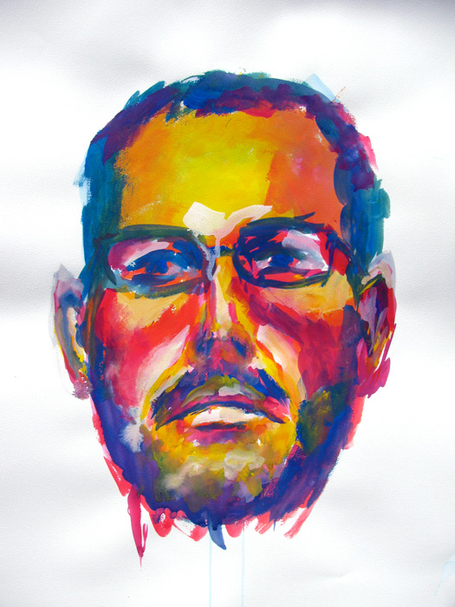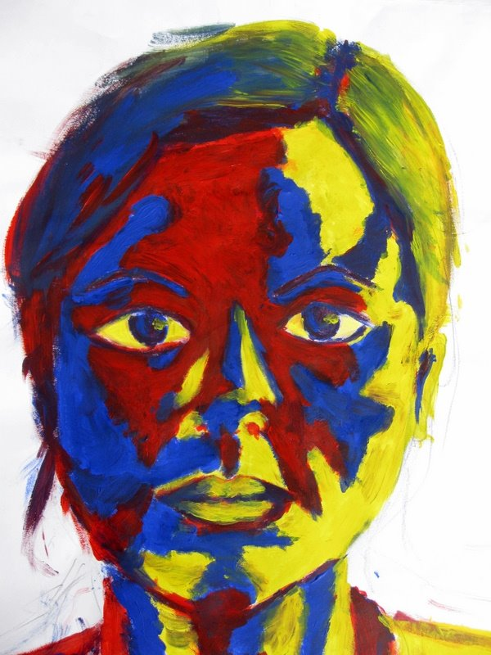

Teacher: Simone Williams
Lesson Title: Primary Portraits
Grade: 8th
Brief History: A portrait is typically defined as a representation of a specific individual, such as the artist might meet in life. A portrait does not merely record someone’s features, however, but says something about who he or she is, offering a vivid sense of a real person’s presence.
Standards: 9.1.12.A, 9.1.12.G, 9.2.12.C, 9.4.12.D
Goals: Draw a portrait of themselves or someone else only using primary colors and black and white
Objectives:
Students will create a portrait using only what they know about the form of their faces
Students will draw the facial details and contour of a classmates face
Students will be able to distinguish the contour, facial features and lines of a face by observation
Requirements: Artist of the day exit card, Hand in peer portrait
Recourses/Materials/Visual Aids:
Artist examples (Piet Mondrian, Jacob Lawrence)
Student examples
Supplies/Materials:
Charcoal paper
Red/blue/yellow/ black/ white pastels
Teacher Preparation:
PowerPoint of artist examples
All supplies
Critique/Evaluation/Assessment: Class discussion on use of colors
Extensions: Full figure drawing, free draw
Time Budget: Week (45min class)
Day 1: Introduction of lesson
Presentation of artist work
Brief primary color refresher
Pictures taken for portraits
HW: Take picture for portraits
Day 2: Studio day
Schematic of face demonstration
Day 3: Studio day
Day 4: Studio day
Day 5: Studio day first 20 minutes then critique and discussion for the rest of class
Vocabulary: Primary colors, Value, Portrait, Highlight, Contour, Schematic
Safety Concerns: None
Bibliography/References:
https://www.metmuseum.org/toah/hd/port/hd_port.htm
https://artclasscurator.com/color-in-art-examples/

