Simone Williams
Lesson Plan Title: Dimensional Landscapes
Grade: 5th
History: “The tradition of landscape painting, in any form, was born from centuries of evolved painting styles, beginning with the tinted walls of the ancient Greeks. Adorning their walls with beautiful gardens and rolling hills was initially common but eventually these scenes became the backdrop for religious stories.”
PA. ACADEMIC STANDARDS FOR THE ARTS AND HUMANITIES:
9.1.5B Recognize, know, use and demonstrate a variety of appropriate arts elements and principles to produce, review and revise original works in the arts.
9.1.8H Demonstrate and maintain materials, equipment and tools safety at work and performance spaces.
9.1.5J Apply traditional and contemporary technologies for producing, performing and exhibiting works in the arts of the works of others.
9.2.5C Relate works in the arts to varying styles and genre to the periods in which they created.
9.4.5D Explain choices made regarding media, technique, form, subject matter and themes that communicate the artist’s philosophy within a work in the arts and humanities.
OBJECTIVES:
KNOWLEDGE: Cognitive. Students know what a landscape is and have examples of some. They know how to use the basic supplies; hot glue gun, paint, paint brush, markers
SKILL: Psychomotor. Students will learn a different approach to creating dimension on a flat surface. They will learn how the layering process of a landscape and how to differentiate the foreground from the background. Students will be reminded how to safely use hot glue.
ATTITUDE. Affective. Students will learn the vocabulary words foreground, background, focal point. They will know a new method for adding dimension and be able to use that method in other art pieces.
PREPARE AHEAD: Pictures of landscapes to inspire and warm up hot glue guns. Pre-cut construction paper or cardboard.
Motivation:
“Does everyone know what a landscape painting is?”
“Show of hands, who has made one before?”
“Here are some examples of landscapes you may have seen before”
“Can you think of any real life scenes or settings you have seen that would be considered a landscape?”
“I first want you to take 5 minutes to sketch that landscape. It doesn’t need to be perfect, it’s only for you to look at.”
“While you do that, I will also take these 5 minutes to draw a landscape scene I can think of.”
“We are going to create landscape paintings today, but not the usual way you were taught before. We will be adding a layer of dimension to our paintings using hot glue, making them 3D”
“Does everybody know what he term 3D means?”
“Can anybody tell me how we may be able to make our paintings 3D using hot glue?”
“You know the process of creating a landscape is layering but on the last layer, we will adding hot glue to add dimension on any object you chose.
Landscapes:
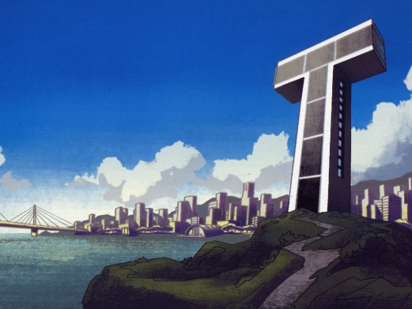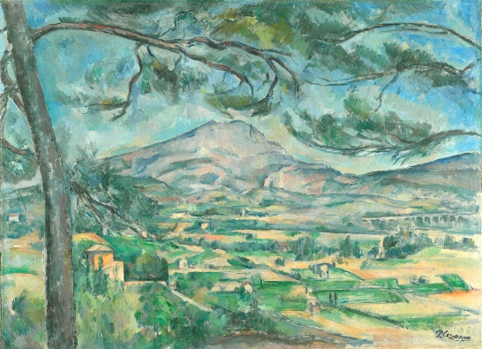
Art history reference: Artists have been painting the landscape since ancient times. The Greeks and Romans created wall paintings of landscapes and gardenscapes. The term "landscape" actually derives from the Dutch word landschap, which originally meant "region, tract of land" but acquired the artistic meaning, "a picture depicting scenery on land" in the early 1500s. Artist like
Questions and Statement leading project:
“Show if hands, how many of use have used a hot glue gun?”
“Who can tell me some dos and do nots when using a hot glue gun”
Introduce the hot glue gun method.
“I am going to demonstrate how to create a tree in the foreground of my landscape using the hot glue gun.”
“Make sure you first draw what shape or object you want and where you want it before you using the hot glue.”
Let children choose their own colors of supplies.
Examples of work:
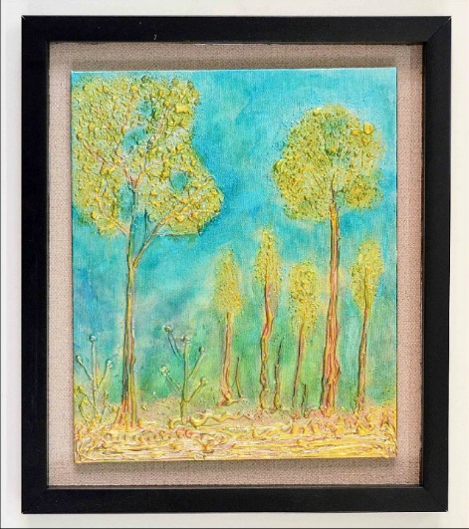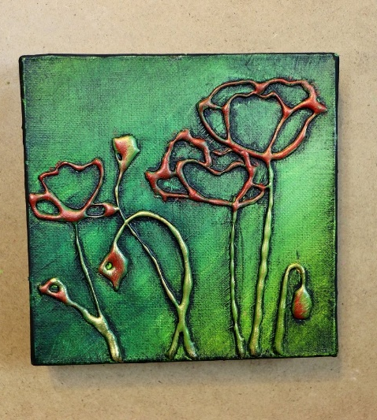

ACTIVITY:
Week 1- Lesson and start of landscape projects
Week 2- Refresh on lesson and finish landscapes
SUPPLIES: Colored construction paper, cardboard, acrylic paint, markers, hot glue guns and extra hot glue sticks
VOCAB: Foreground, Middle ground, Background, Focal Point and Dimension
CLOSURE: Elaborate on other types of paintings and crafts this approached would be handy for.
ASSESSMENT STRATEGY: At the end of this project, students will have a better understanding of how simple it is to make a 3d work of art and a new way to use a hot glue gun. They will also know how to now add dimension to almost anything.
EXTENSIONS: Students that finish early will be able to help those around them or read/color in the reading corner.
ADAPTATIONS: Extra time will be given to students if needed. I will assign a student helper or I will hand over hand assist anybody who needs help with the hot glue gun. Elmer’s white glue can be a substitute for those afraid or unable to use the hot glue guns (this will need extra time to dry).
Down syndrome: Children with Down syndrome may become easily distracted, so it is best to first seat them closer to where I plan on spending a majority of the class period. I will not single the student out but have them stand next to me during demonstration. Children with Down syndrome tend to benefit from group instruction more, so a class friend or student helper that the child is comfortable with may sit with them and help them along the way. I understand that a child with Down syndrome may need extra attention during projects, but my goal is to not make that child uncomfortable. I will encourage them on the way and help as much as needed but if they do something wrong I will explain why I am looking for something different and have them correct it.

Sources:
http://www.getty.edu/education/teachers/classroom_resources/curricula/landscapes/background1.html
https://en.wikipedia.org/wiki/Paul_Cézanne
http://www.getty.edu/education/teachers/classroom_resources/curricula/landscapes/background1.html
https://sites.google.com/site/robinsonindependentresearch/home/fine-motor-skills
http://www.dsahrc.org/professional-resources/educators/item/41-tips-for-teaching-students-with-down-syndrome
Pictures:
http://fanaru.com/teen-titans/wallpapers/
https://www.cnn.com/style/gallery/the-courtauld-gallery/index.html
https://www.mccannteam.com/changing-the-landscape-of-philadelphia/
http://blog.itsybitsy.in/hot-melt-glue-and-metallic-paints-wall-art/
https://www.pinterest.com/pin/42291683974726714/?lp=true
https://www.herpetologistsleague.com/glue-gun-painting.html

